**Features and information about the framework:**

**Language:**Selenium + Java  
**Type of Framework:**[Data-driven Framework](https://www.softwaretestingmaterial.com/data-driven-framework-selenium-webdriver/) by using [Page Object Model design pattern](https://www.softwaretestingmaterial.com/page-object-model/) with Page Factory.  
**PageObjectModel:**we have maintained a class for every web page. Each web page has a separate class and that class holds the functionality and members of that web page. Separate classes for every individual test.  
**Packages:**   
We have separate packages for *Constants*, *Pages* and *Tests*. All the *web page* related classes come under **pages** package and all the *tests* related classes come under **tests** package, all constants related classes comes under **constants** package

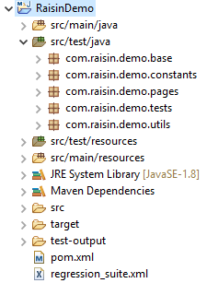

The framework also generates Extent reports and display logs in console.  
**How to Execute:**You can rightclick and select “Run as TestNg tests’ to execute the tests and view the report.

